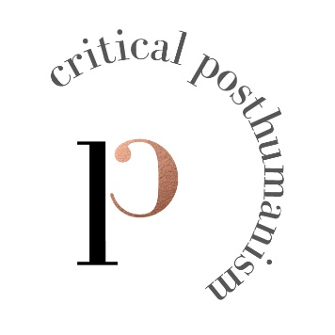

Genealogy of the Posthuman: Call for Entries

What exactly is ‘the posthuman’? What are the nonhuman and the inhuman? What, for that matter is the human? How have these ideas been conceptualised, historicised, framed and reframed in philosophy, literature, critical thought, the sciences and the arts? How can they be critiqued and rethought?

These are some of the questions addressed in the Genealogy of the Posthuman, a growing peer-reviewed, online and multi-authored resource that traces the prefigurations, currency and evolving potential of contemporary thought on the posthuman.

We invite contributions by academics, researchers and doctoral students from all disciplines that explore posthumanist questions, issues, tensions in the work of a given author or thinker, or in a particular theme or motif. The Genealogy features entries informed by the re-examination and critique of posthumanism’s acknowledged, unsuspected and evolving dimensions.

Entries should be informative and should seek to make a critical intervention in the field. Submissions may consist of a standalone entry or one that is linked to and engages with existing contributions. Prospective contributors are invited to browse the entries already published on the site (http://criticalposthumanism.net/genealogy/) to familiarise themselves with the Genealogy’s form and rationale and to identify potential areas of interest.

Submissions should be around 1000 words in length and should include up to 8 keywords. Images and video clips may also be included with submissions. Contributors are requested to follow the MHRA style sheet (www.mhra.org.uk/index.php/series/MSG) and all references should appear as footnotes. Articles are to be submitted as a Word document, in the form of an email attachment. All entries are peer-reviewed and authors can expect attentive and helpful feedback.

For more information about Critical Posthumanism and the Genealogy project go to http://criticalposthumanism.net/about/. Email info@criticalposthumanism.net for further details or enquires.

Submissions are to be sent to submissions@criticalposthumanism.net.

